Technical report of project Bio&Health

## Andreas Nalmpantis – 3699, Ioannis Oikonomidis – 3668,

## Chris Papakonstantinou – 2499, Iordanis Kokkinidis – 3412

## 1 April 2022

# Introduction

This is the second part of our 3-part project. In this stage we completed the front-end side of our website. The technologies that were used were HTML, CSS, JavaScript and Bootstrap to help us make the website responsive. In this report, a quick description of each page of our website will be given, describing each page’s main functions, our thought process and what remains to be done in the third part, in which we will develop the back-end for our site.

# Front end

Header  
The header is included in every file of our website. It provides some quick navigation shortcuts to the user and some links to pages related to the user’s account.

First, it contains a “burger” menu which, when clicked, reveals a list of links for every product category in our store. When the user clicks one of these links, he will be transferred to a different page which will display all the products of the selected category.

Then we have the Bio&Health logo. It is a link which acts as a home page button.

After that, there is a search bar. The user can type in the product he is looking for, or keywords related to what he is looking for, and he will be transferred to a different page with the results, depending on what he typed.

In the end, there are 3 icons, the “account” icon, the “cart” icon, and the “favorites” icon. The account icon contains a dropdown menu, with links that provide the way for the user to sign in or create a new account, or (if he is already signed in) to edit his account information and log out. The cart icon opens the cartpage.html file, which displays the products that the user has added to his cart and the favorite icon opens the favorites.html file which displays the products that the user has added to his favorites.

To create the header, we used plain CSS and Bootstrap for the layout and some utilities.



Footer  
It is also included in every page and is located at the bottom of it. It contains some general information about the store and several ways of contact.

The first section under the “Contact” heading has some contact information along with the link “contact form” which takes the user to the contactForm.html page in which he can write a message to the administrator.

The second section contains some location information for our store and the last section contains links for our social media accounts. The icons both in the header and the footer are taken from [font awesome](https://fontawesome.com/) and so are all the other icons used in any page.

To structure the footer and make it responsive, we used the Bootstrap grid layout (classes row and col)



Index.html

The home page of our website. It contains various links and media content for the user.

At the top of the page there is a slideshow, which will contain some representative content for different parts of our website and will link to them, giving those parts more visibility and providing easier navigation for the user. The content will be filled during the third stage of the project, when all the products will be added.

In the middle we have a section which displays all the product categories that we have in our store. Both the images and the text are links which will take the user to the search page, displaying all the products of the selected category.

Lastly, we have some more representative content for different things, such as new products, offers, and some useful information regarding our store.

For the layout of the page, we used the Bootstrap grid and flexbox. For the slideshow, we used the Bootstrap class “carousel” along with all of its subclasses. For styling, in this page and all of the pages, we used plain CSS and Bootstrap utilities.

The current images are just placeholders and will get replaced later on.

Εικόνα που περιέχει κείμενο, χλόη, υπαίθριος, στιγμιότυπο οθόνης

Περιγραφή που δημιουργήθηκε αυτόματα

Εικόνα που περιέχει κείμενο, διαφορετικός, στιγμιότυπο οθόνης, αρκετά

Περιγραφή που δημιουργήθηκε αυτόματα

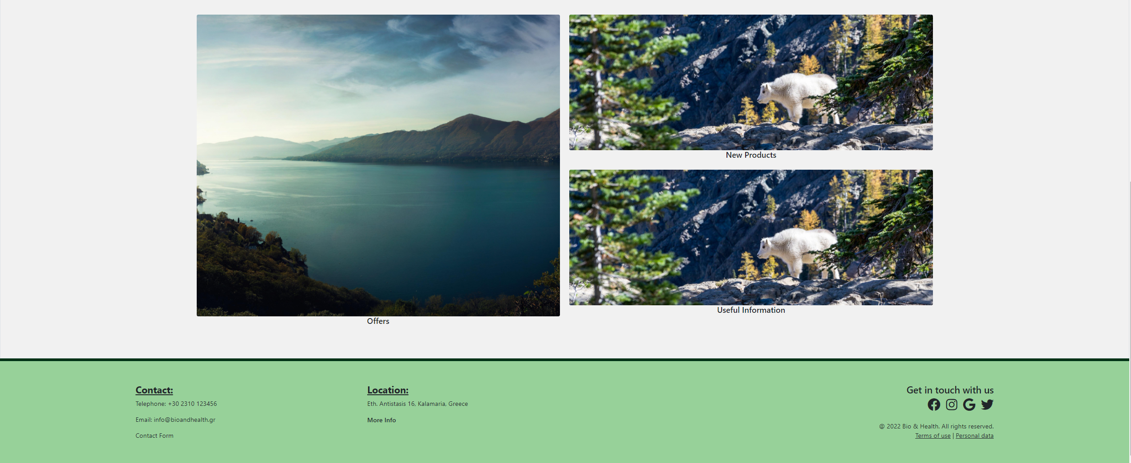

Sign_up.html

This is where the user creates his account. It contains a form in which the user gives his account credentials (email, username, and password) and submits. There is also the option of creating an account using one of his social media accounts.

The user also has the option to go to the sign in page if he already has an account by the “Sign In” button located in the right of the page.

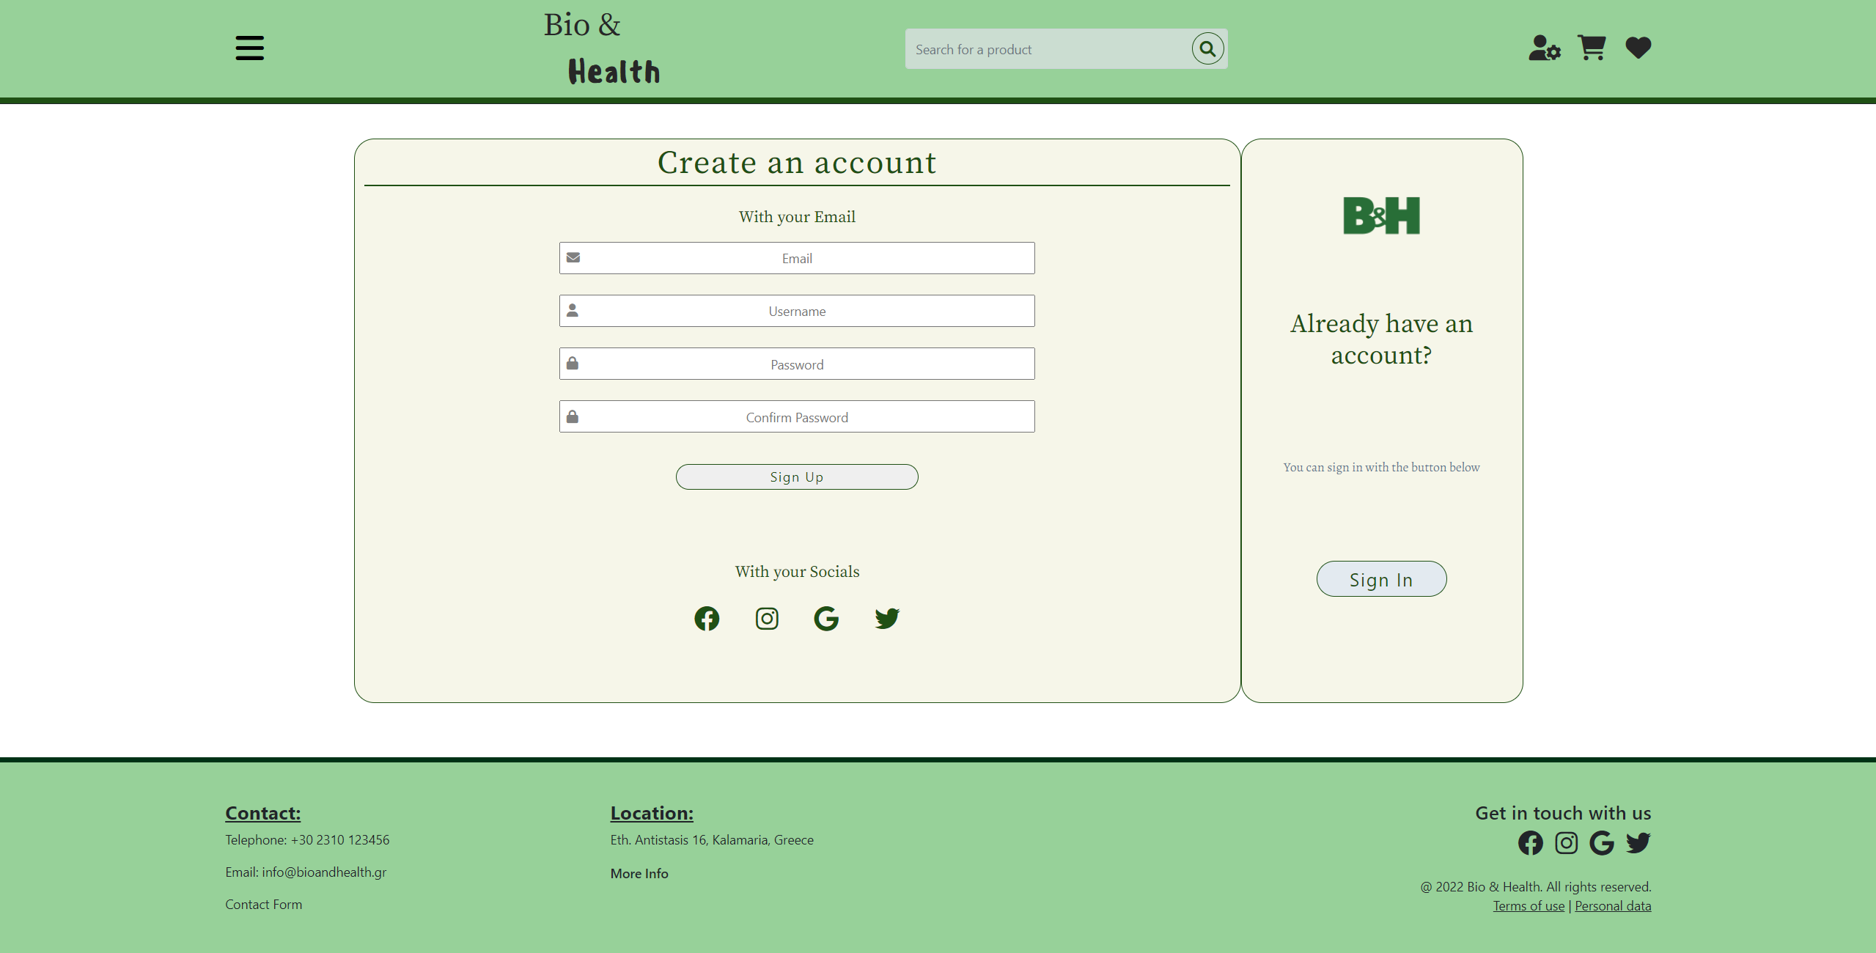

Sign_in.html

Similarly, this page is where the user signs in. He types his credentials in the given form and submits. He can also sign in using of his social media accounts and he can go to the sign-up page through the “Sign Up” button.

For the layout of both the Sign Up and Sign In pages, we used the Bootstrap grid, and flexbox.

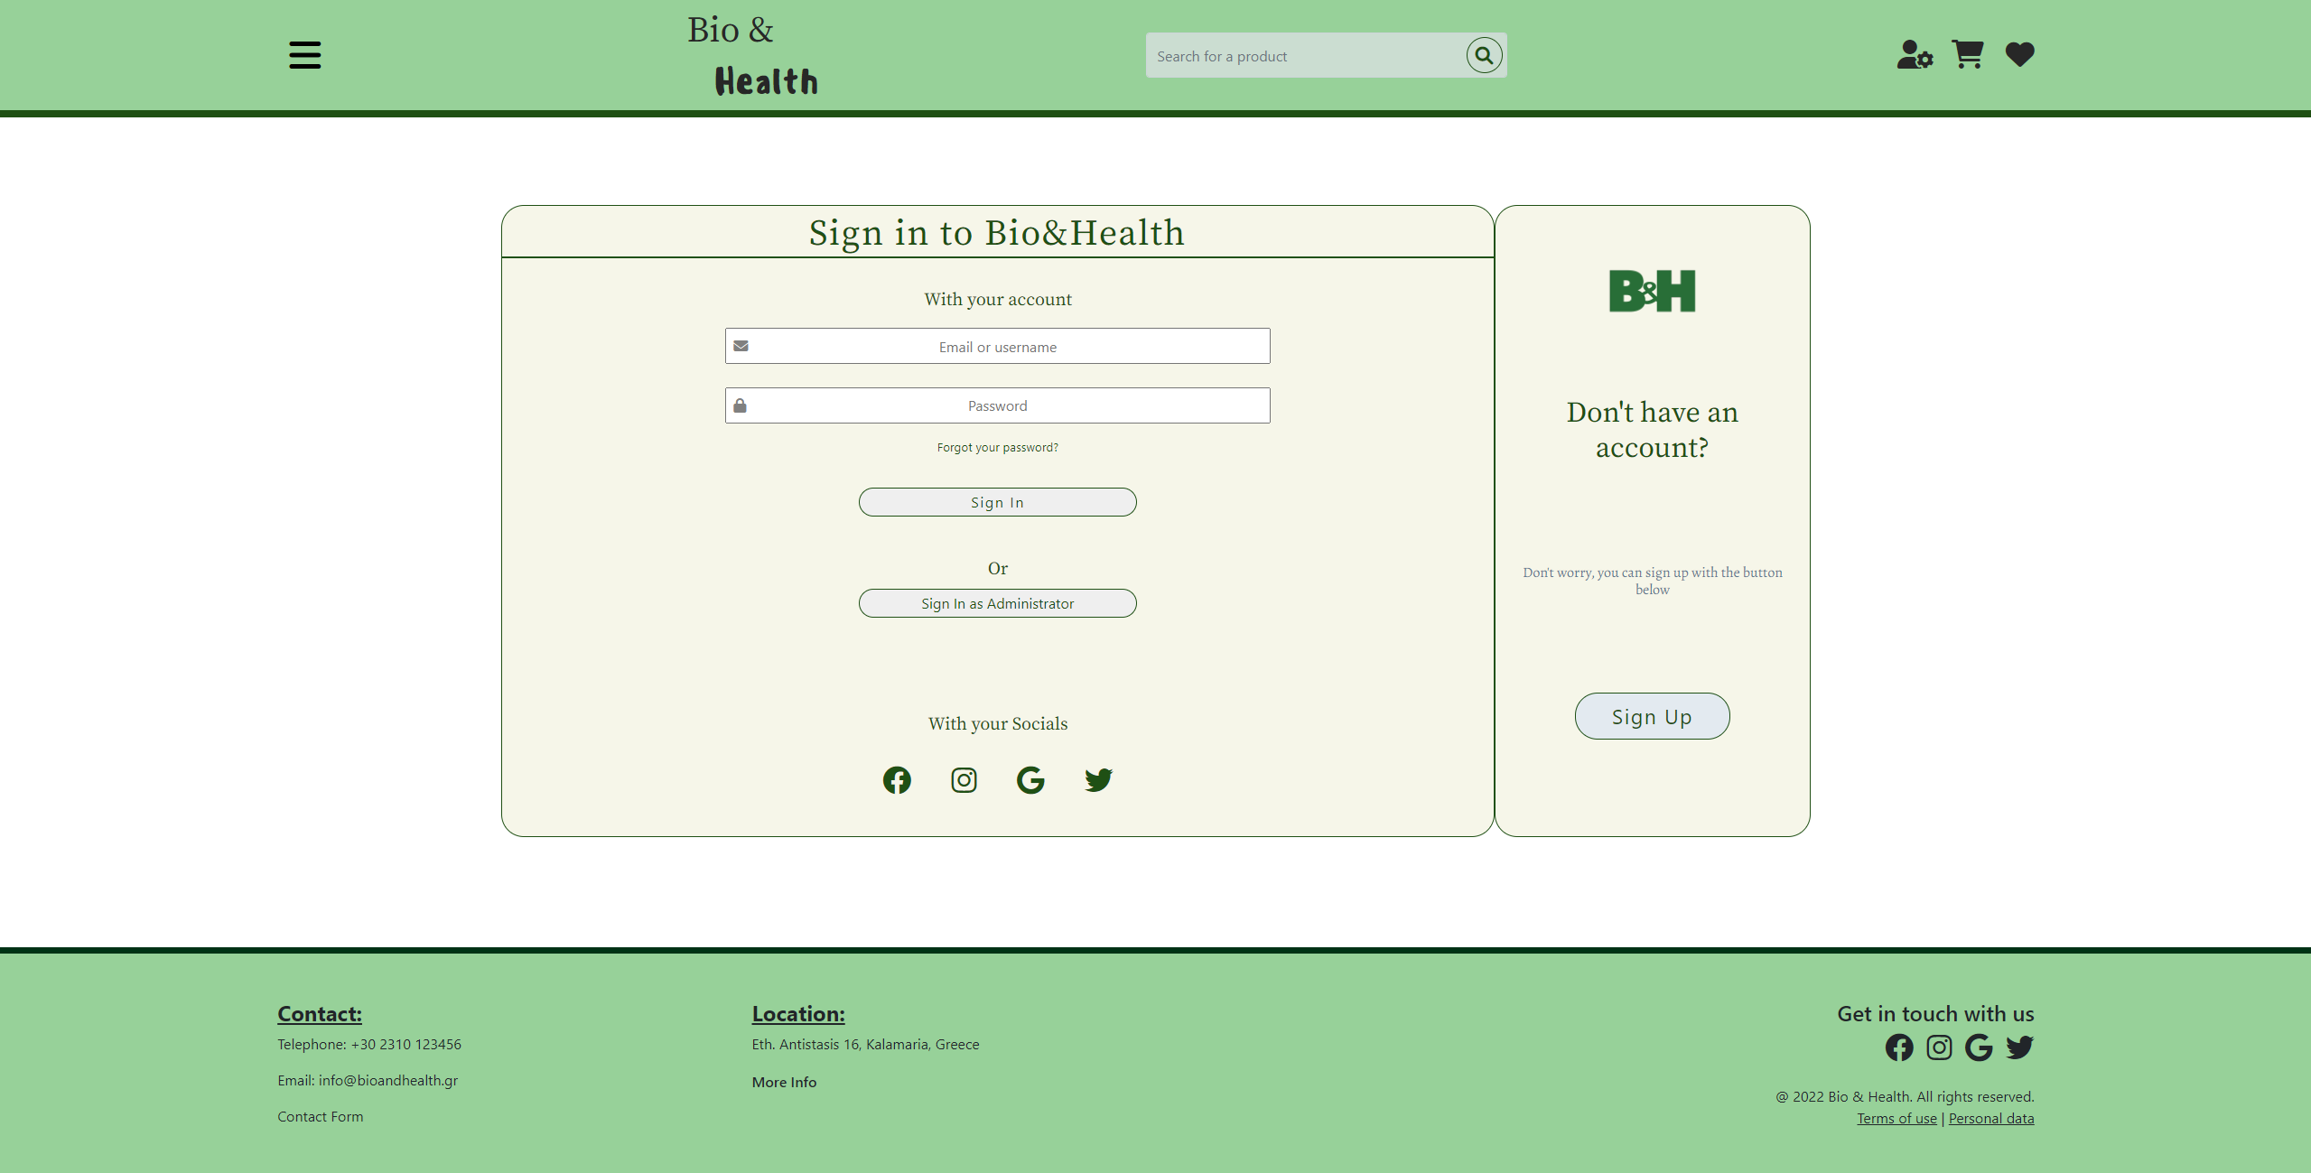

Account_info.html

In this page, the user can edit his account information. The fields, when the back-end is completed, will display the information given by the user and he will then be able to change it by editing the fields and submitting the form.

A similar layout has been used for this page, using mainly flexbox.

Εικόνα που περιέχει πίνακας

Περιγραφή που δημιουργήθηκε αυτόματα

New_product.html

In this page, the admins will be able to add a new product for the store by typing the required information of the form and submitting. The page also contains a list of the product categories available and an option to add a new category.

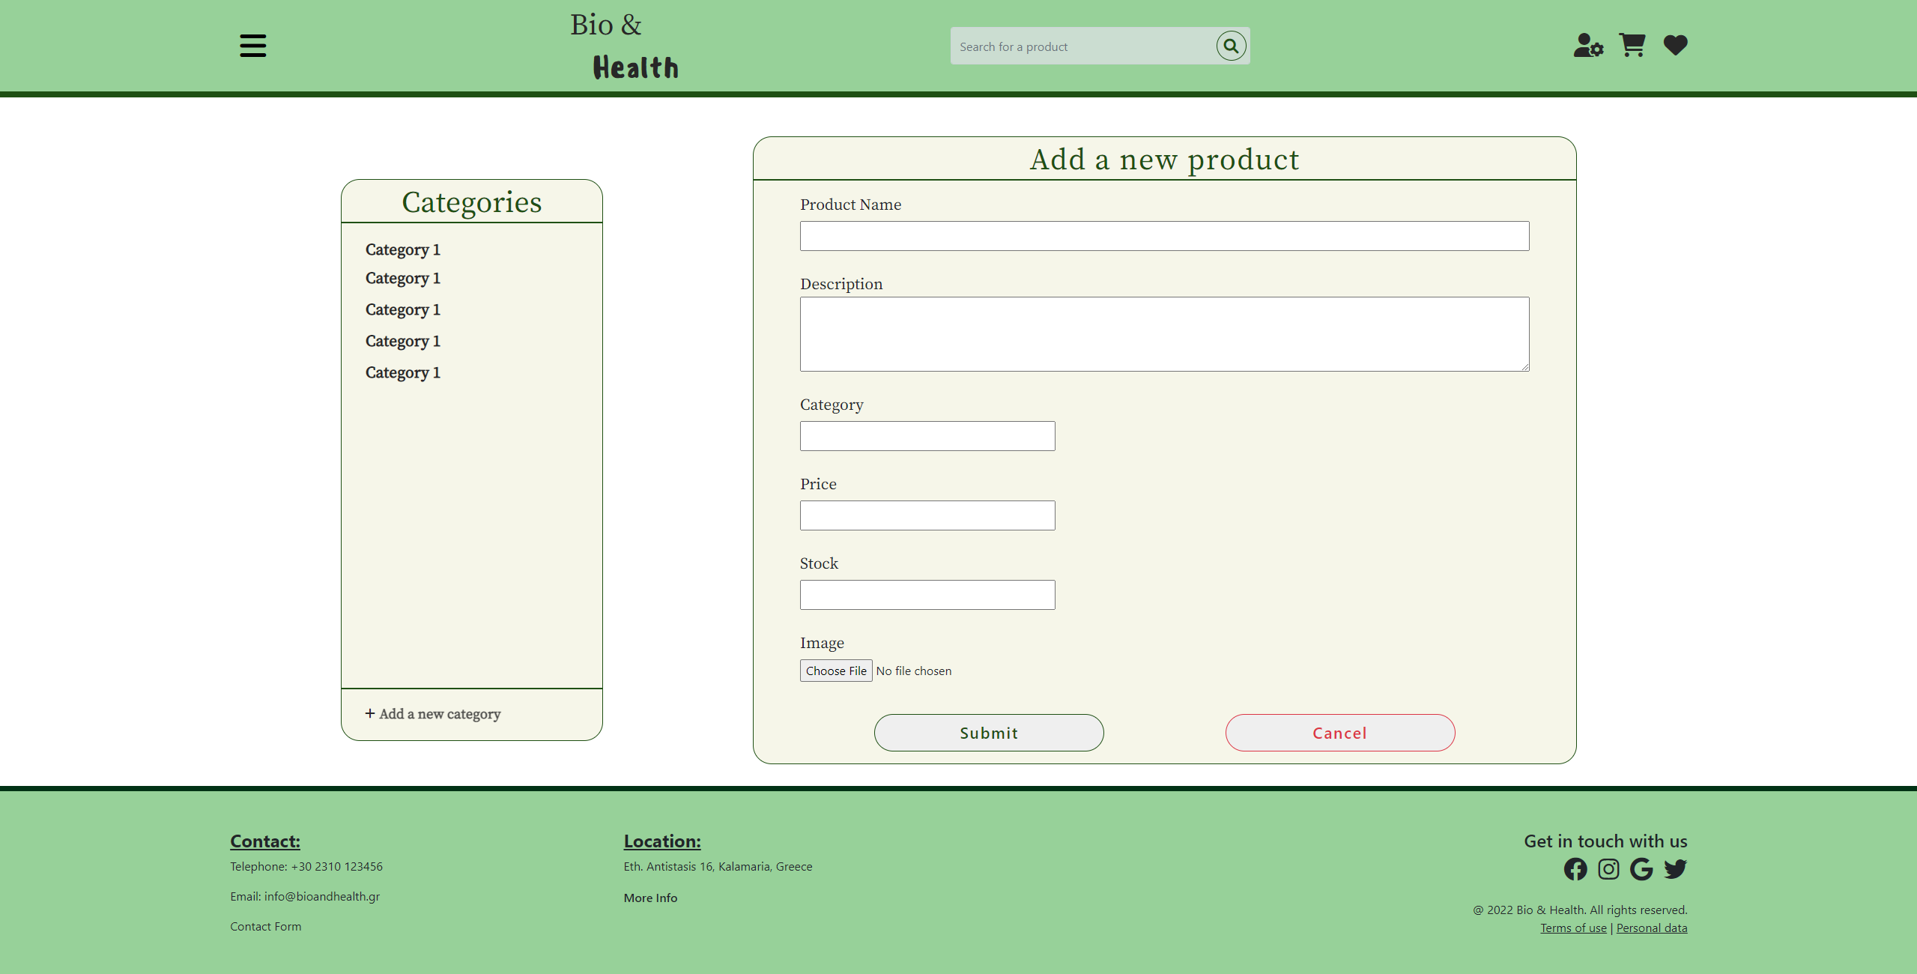

Edit_product.html

Similar page, in which the admin can edit the information of a product, in case something has changed, or he made a mistake.

Both the new product and edit product pages use the same layout as the previous pages, which means they are structured using Bootstrap grid and flexbox.

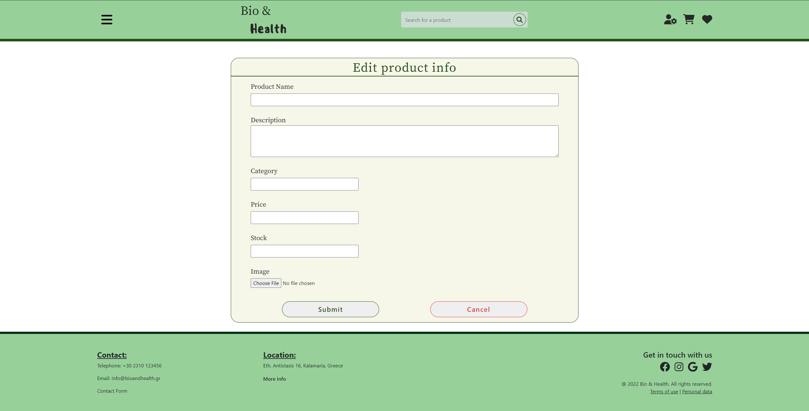

Searchpage.html

Cartpage.html

Completionpage.html

Checkoutpage.html

contactForm.html

completeorderspage.html

contactCompletionPage.html

favorites.html

The favorites page contains a table of the favorite products of the user, together with information about these products. For each one of the favorite products, the page shows the product’s name and its price. The layout of the page is created by using the table tag of HTML5 and tr and td tags to declare the rows and the content of all the cells of the table. A user can visit the favorites page when he/she clicks on the small heart shown on the right side of the header of all pages.

A screenshot of the page is shown in the following figure:

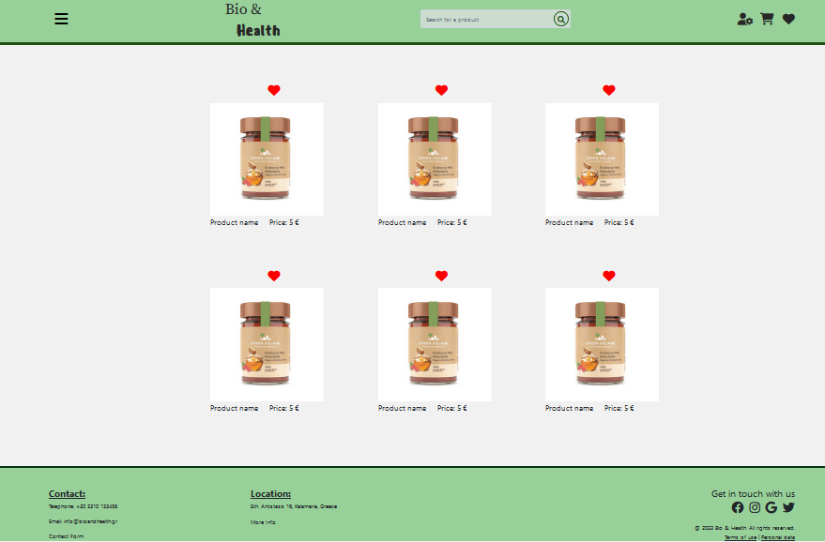

When the user clicks on the picture of a products, then the page containing detailed information about the program appears, as it is described below.

infopage.html

The product information page contains detailed information about a product, as is shown in following figure:

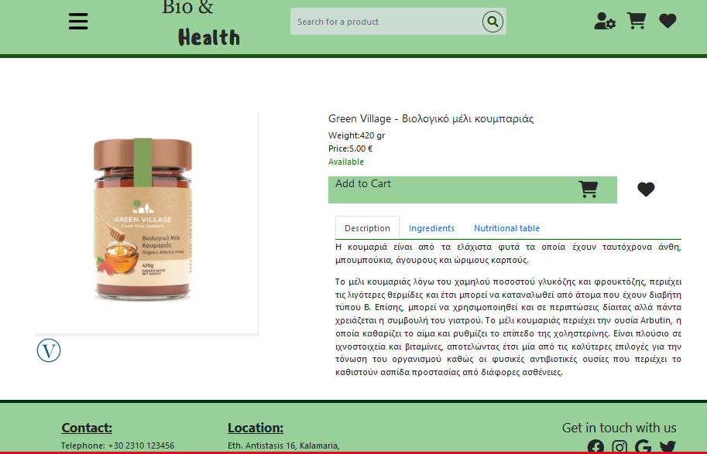

The information contains the product’s picture on the left side and other useful information about the product on the right side. For every product, the information depicted contains elements like the product’s name, the weight, and the price of the product, together with the description, the ingredients, and the Nutritional table of the product. This information is shown in a tabbed layout, so that the user has to select the name of a tab in order to read the related information.

The user can click the cart picture to add the product to the cart or the heart picture in order to add the product to the favorites or to remove it from the favorites list. The layout of the page was developed by using the Bootstrap library and the same library was used to create the tabs that contain the information.

Εικόνα που περιέχει κείμενο

Περιγραφή που δημιουργήθηκε αυτόματα

info.html

admincartpage.html

adminsearchpage.html

# Next steps